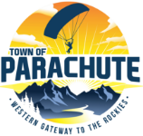
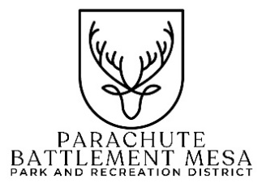
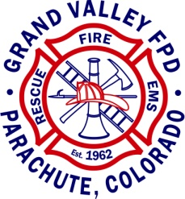

Prescribed burning planned at Parachute/Battlement Mesa Park & Recreation District and Town of Parachute open space, north of Cottonwood Park Ball Fields

Parachute, CO – The Grand Valley Fire Protection District will be conducting prescribed burning operations in the open spaces along Parachute Creek north of Cottonwood Park Ball Fields. Burning operations will occur as weather conditions permits and could begin the first week of November and extend into December. Please do not call 911 to report smoke in this area.

Burning will only be conducted under specific guidelines and plans established by the Grand Valley Fire Protection District Prescribed Fire Plan, including having acceptable weather forecasts and fuels conditions that meet guidelines for safe and effective burning and adequate smoke dispersal. The main objective of this prescribed burning project is to burn slash piles created as part of the Parachute Creek Fire Mitigation Project.

The Grand Valley Fire Protection District work closely with other agencies, such as the Colorado Air Pollution Control Division, Garfield County Public Health, and local authorities in developing and implementing any burning project. Prescribed fire smoke may affect your health. For additional health-related information, visit https://cdphe.colorado.gov/indoor-air-quality/wood-smoke-and-health or contact your doctor or health professional.

Media/Public Information Contact:
Grand Valley Fire Protection District: Kim Reeves (970) 285-9119

