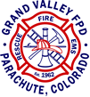

JOB ANNOUNCEMENT
Lead Wildland Seasonal Firefighter
$22.00 – 26.00 per hour based on qualifications

May 23, 2022 to Sept. 10, 2022 (may vary due to fire season)

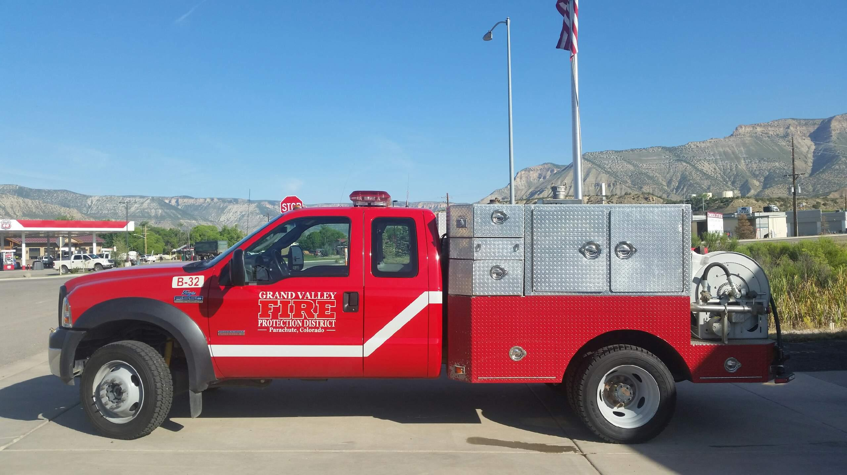

DESCRIPTION
Grand Valley Fire Protection is seeking applicants for the Seasonal Wildland Firefighter program.

Applications and Certifications should be submitted to:
Deputy Fire Chief Chris Jackson
opschief@gvfpd.org
Fax: (970) 285-9748
Physical and Mailing: 0124 Stone Quarry Road, Parachute CO. 81635

Application can be obtained on our website: www.grandvalleyfire.org
Submission deadline is 1700 hours on Friday May 13, 2022
Grand Valley Fire Protection District is an Equal Opportunity Employer.

POSITION SUMMARY

Works under the general supervision of the Deputy Fire Chief. Serves as a wildland firefighter supervisor on a wildland engine. Independently performs engine operations duties in the suppression of wildland fire. Works with Chief staff and on duty crews to perform property assessment and mitigation assignments as assigned.

BENEFITS

- Competitive wages
- Bi-weekly payroll
- Basic life and accidental death and dismemberment insurance
- Opportunities for training

PRIMARY DUTIES AND RESPONSIBILITIES

The Lead Wildland Firefighter will be expected to:

- Drive/operate the various wildland apparatus with consideration of safety of crew and equipment.
- Establish command and function within the ICS system.
- Identify land ownership on an incident and notify appropriate authority as needed.
- Research weather forecast and keep crews updated on daily predictions.
- Personally perform and/or assign pump and suppression operations.
- Direct hose lays and nozzle operations in effective use of water and additives.
- Specialized duties, such as chain saw operations.
- Operate in a hand crew capacity to construct fire-line, with hand and power tools.
- Working with crew to inventory and maintain fire equipment, apparatus and facilities.
- Perform minor repairs to district equipment.
- Work well with the general public, volunteers, and staff of the GVFPD and partner agencies.
- Conduct fuel mitigation and wildland fire suppression in the Grand Valley Fire Protection District.
- Completes accurate and timely response records.
- Performs fire prevention activities, public relations and education, inspections, and code enforcement.
- Provides and participates in training.
- Continually monitors the fire situation in relation to accepted safety practices and guidelines.
- Assists with GVFPD projects and programs as needed.

PHYSICAL AND MENTAL REQUIREMENTS

The physical and mental strength and endurance to be able to perform strenuous duties for prolonged periods of time in extremely hazardous conditions, as well as the ability to handle severe stressors of the position in operational and administrative situations. Required to frequently lift and move 30-74 pounds and occasionally lift and move 75-180 pounds. Expected to stand, sit, walk, climb, balance, stoop, kneel, crouch, crawl, bend, talk, hear, smell, and use hands and fingers to handle and operate objects, tools and controls and reach with hands and arms. Vision must be in good condition or corrected for close, distance, and peripheral vision as well as depth perception and ability to adjust focus. Must be able to participate in physical conditioning activities for up to one hour each day. Be able to handle deployments to wildland and all hazard events, to areas with limited living comforts.

Required Qualification:

- At least 18 years of age
- Excellent health, free from any mental or physical condition, which would interfere with effective performance on the job.
- Successful current year’s Work Capacity Test: Pack Test (arduous)
- Must provide proof of /or submit to a Hepatitis-B vaccination series or sign a refusal.
- Possession of a high school diploma or GED.
- Possession of a valid Colorado Driver’s License.
- Sign the District’s Authorization Request for Colorado driver history report. If applicant has not lived within Colorado for the past 3 years, a previous state driving history report will be required as well.
- Sign the District’s Authorization Request for a Colorado Bureau of Investigation “Criminal Background History”. If the applicant has not lived within Colorado for the past 3 years, a Federal Bureau of Investigations “Criminal Background History” report will be required.

Required Certifications:

- NWCG qualified Engine Boss (NWCG Firefighter I with Engine Boss task book initiated minimum)
- ICT 5 or higher
- Fal2 (B)
- Certified in First-aid and CPR (Will provide if not currently certified)

Additional Preferred Certifications:
- FAL1
- Colorado Firefighter I - Structural
- EMT-B – State of Colorado

SCHEDULE

40-hour work week / 4/10 shifts (Sunday - Wednesday or Wednesday – Saturday), plus incidents, and call-backs

EMPLOYMENT PROCESS:

- Applications will be reviewed, and the Deputy Fire Chief will notify via email
- Interview will be scheduled with Fire Chief and Deputy Fire Chief.
- Conditional offer of employment
- Background check will be performed (non-members)
- Physical will be scheduled (non-members)
- Arduous Pack Test will be scheduled (unless already completed)
- Job offer and announcement May 16, 2022.
- Start day week of May 23, 2022 (Orientation and paperwork)

